
AIMS
- To learn and use in the children’s life gratitude
- To identify a personal experience with feeling grateful
- To get the different ways of expressing gratitude
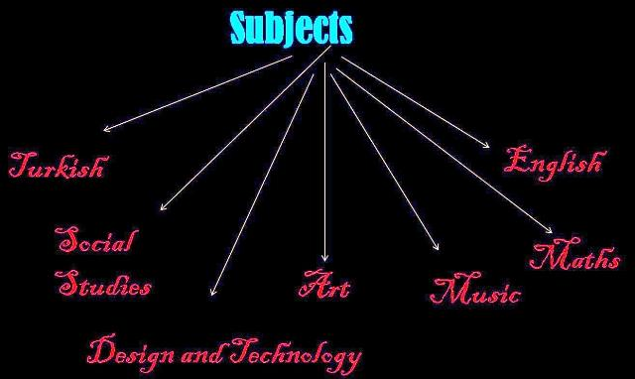
TOPICS
- Preparing ‘Thankful tree’
- Drawing competition
- Number Codes
- Writing about what you are grateful for
- Explaining and writing gratitude messages
- Taking part in a play for being thankful
- The gratitude stars
- The Thankful tree
- The play
- Visits to the grannies
- Grateful poems

ACTIVITES

